Traverse to below location and open configuration file

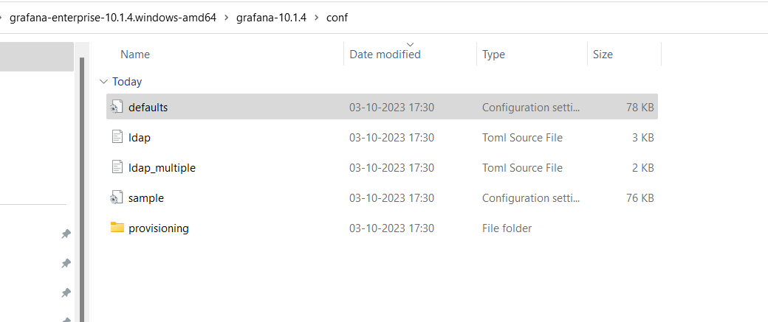

File name “defaults”

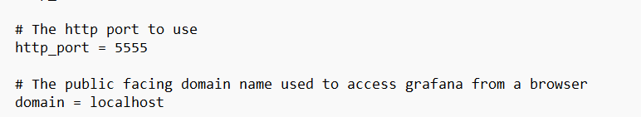

Now lets create Grafana server to be run as windows based service so we don’t have to start it manually everytime we start our machine.

Download NSSM software from below link

[NSSM - the Non-Sucking Service Manager](https://nssm.cc/download)